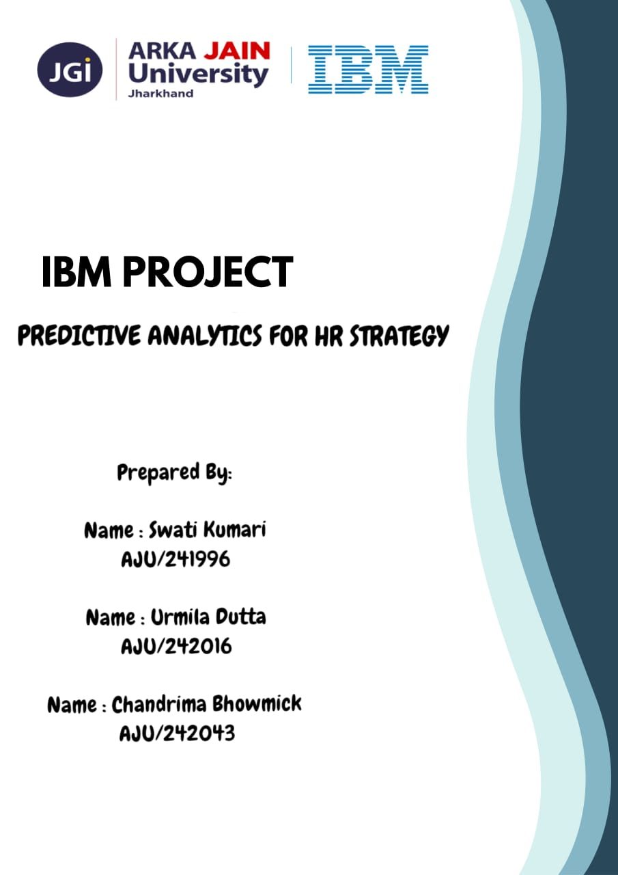
INDEX

SR NO. | TOPIC | PAGE NO.
1 | SUMMARY | 3
2 | INTRODUCTION | 4-5
3 | MODEL 1 | 6-9
4 | MODEL 2 | 10-13
5 | MODEL 3 | 14-17
6 | MODEL 4 | 18-21
7 | CONCLUSION | 22

SUMMARY

In this project, we explore both predictive and descriptive methods to understand and forecast employee attrition using the IBM HR Analytics dataset. We developed three predictive models — C5.0, C&R Tree, and Linear Regression — to classify and score attrition likelihood. To complement this, we used Two-Step Clustering to uncover natural groupings in the workforce that may influence attrition. Our evaluation focuses on model performance metrics (accuracy, precision, recall, and ROC AUC) and cluster interpretation. This approach enables HR teams to not only predict attrition but also uncover behavioral patterns across employee groups, improving strategic retention planning.

INTRODUCTION

The effective management of human capital is paramount to organizational success, with two factors—employee retention and perceived fairness in career progression—standing as critical determinants of long-term stability and growth. Unplanned employee attrition results in significant costs related to recruitment, training, and loss of intellectual capital, while inconsistent salary and experience alignment leads to dissatisfaction and a decline in morale among high-performing staff.
This project, titled "Predictive Analytics for HR Strategy," addresses these challenges by developing a robust, data-driven framework using advanced modeling techniques.

Problem Statement :
The organization is facing challenges in employee retention and requires a data-driven understanding of its workforce dynamics. The primary problem is the unpredictable loss of valuable employees (attrition), coupled with the need to ensure fair and transparent career progression to maintain morale.

About the dataset :
The dataset used for this project is the IBM HR Employee Attrition and Performance data (often referred to as WA_Fn-UseC_-HR-Employee-Attrition.csv). It is a publicly available dataset specifically designed for analysing employee turnover.
Domain | Example Fields | Utility in Project
Demographics | Age, Gender, MaritalStatus | Used for segmentation and as basic predictors.
Compensation | MonthlyIncome, DailyRate, HourlyRate | Served as the primary target for the Linear Regression model.
Job & Career | JobRole, JobLevel, TotalWorkingYears, YearsAtCompany | Served as the primary target for the C&R Tree Regression and key predictors for all models.
Workplace Behavior | Attrition, OverTime, JobSatisfaction, EnvironmentSatisfaction | Attrition served as the target for the Classification model and is critical for segment profiling.

MODEL 1

The first model developed in this project utilized the C5.0 Classification Algorithm with the goal of predicting employee Attrition (whether an employee will leave the company).
The C5.0 algorithm works by recursively partitioning the training data into smaller, purer subsets based on the input field that provides the most information gain about the target variable.
- Decision Tree Structure: It builds a tree where each internal node represents a test on an input field (e.g., "Is OverTime = Yes?"), each branch represents the outcome of the test, and each leaf node (the end point) represents the final predicted class (e.g., 'Attrition: Yes' or 'Attrition: No').
- Efficiency: C5.0 is known for its speed and its ability to handle large datasets effectively, making it very robust for real-world business problems like predicting employee turnover.

Steps for creating this model in IBM SPSS Modeler :

Step 1 : 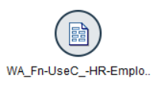

Step 2 : 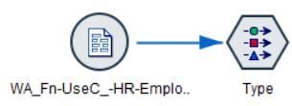

Step 3 : 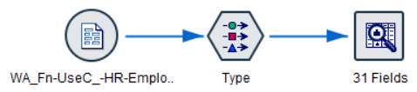

Step 4 : 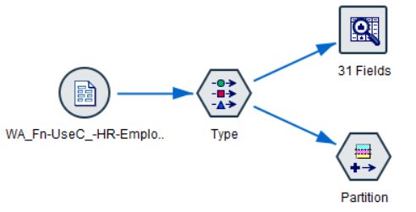

Step 5 : 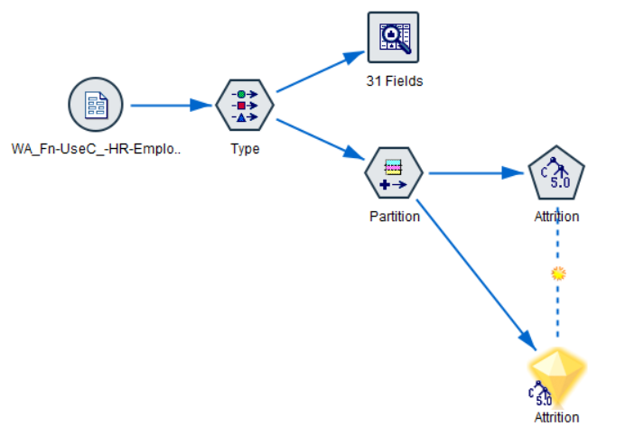

Step 6 : 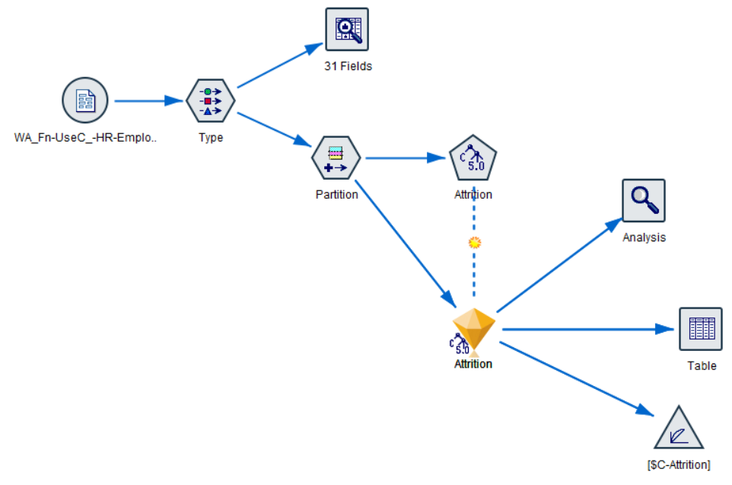

Outputs :

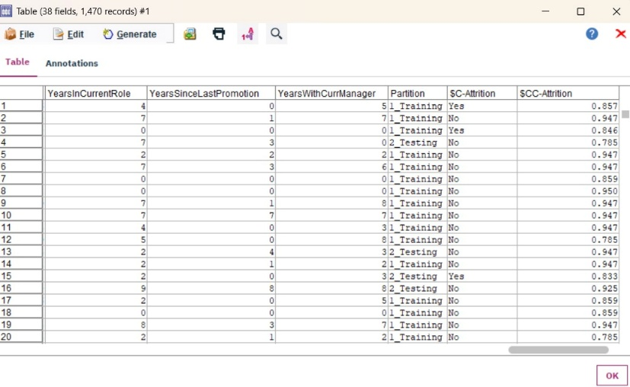
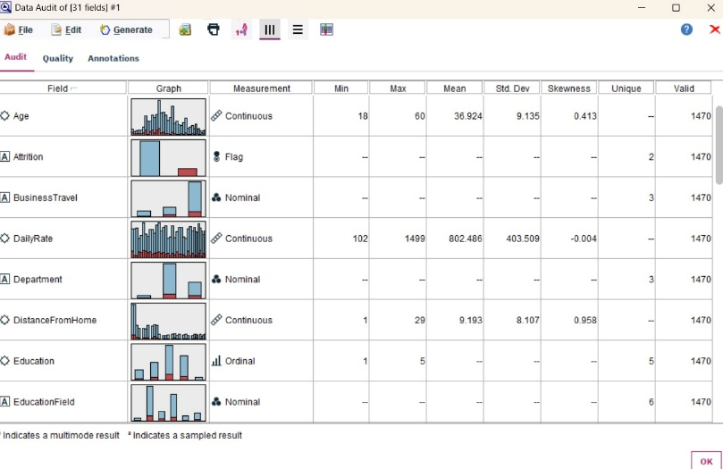
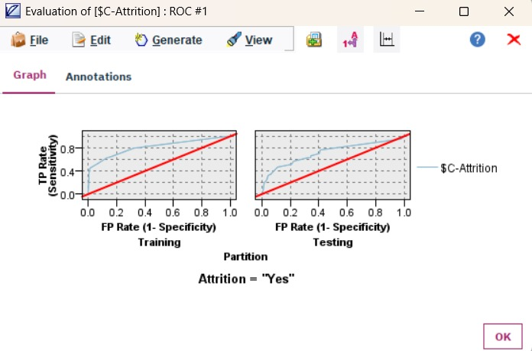

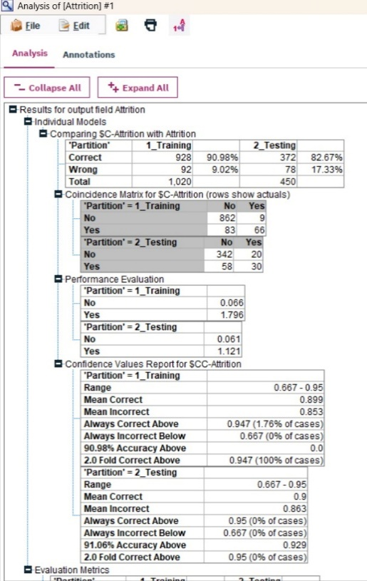
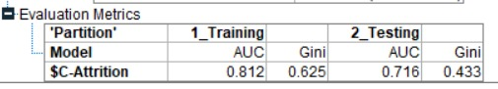

Key insights :
The model's primary goal was to identify employees at high risk of leaving. The key insights reveal a significant challenge in detecting the high-risk group.
Insight Category | Key Finding | Business Implication
Overall Performance | High overall accuracy on the test set: 86.69%. | The model is very good at predicting employees who will stay (Specificity ).
Key Attrition Drivers | OverTime is a dominant predictor of attrition. Low Job/Environment Satisfaction and Low Total Working Years also significantly increase risk. | HR interventions should immediately target employees with low satisfaction who are forced to work overtime.

MODEL 2

The second model employed Linear Regression with the strategic goal of predicting the continuous, quantifiable business metric: Employee Monthly Income. Linear regression is a foundational statistical method used to model the linear relationship between a dependent variable (the target, MonthlyIncome) and one or more independent variables (the predictors, such as JobLevel, Age, and TotalWorkingYears).
The model's core purpose in this project was twofold:
- Compensation Benchmarking: To establish a clear, data-driven formula defining how various factors contribute to salary, effectively creating an internal standard for expected income.
- Fairness Audit: To quantify the precise impact (coefficient) of each predictor to test organizational fairness, particularly regarding tenure and hierarchy.

Steps for creating this model in IBM SPSS Modeler :

Step 1 : 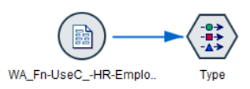

Step 2 : 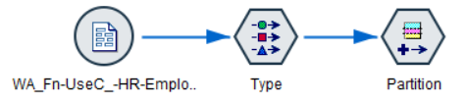

Step 3 : 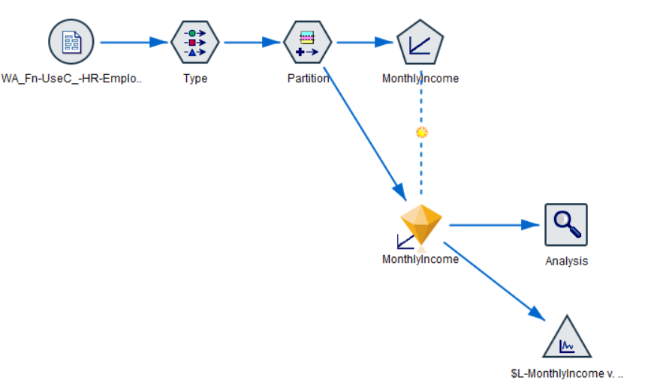

Outputs :

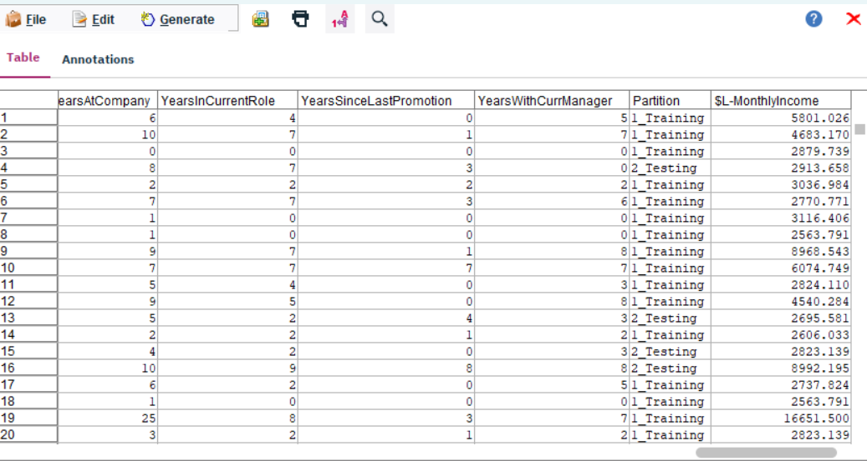
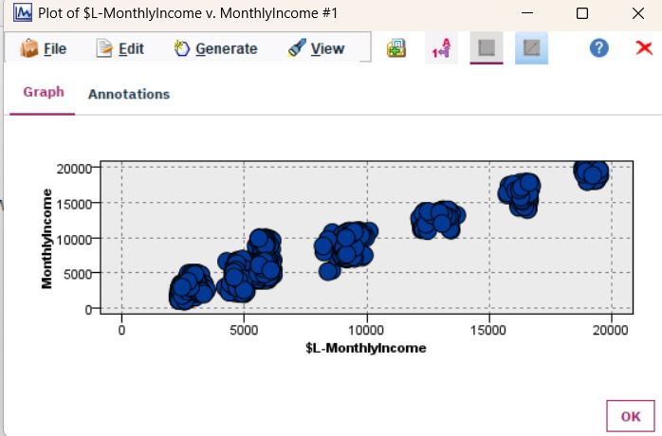
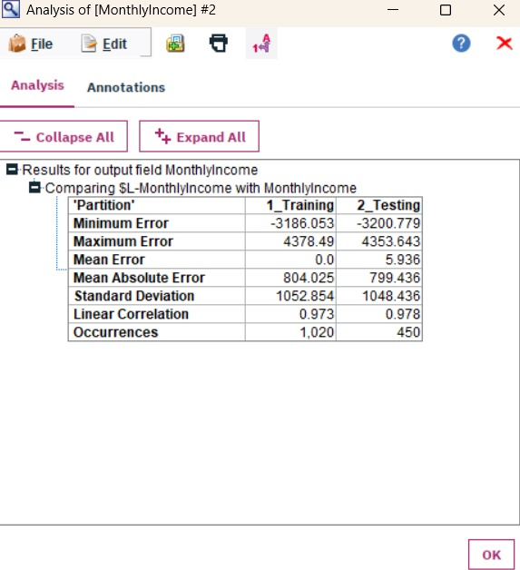

Key insights :
The model's goal was to accurately predict an employee's salary, yielding very robust and high-confidence results.
Insight Category | Key Finding | Business Implication
Model Strength | Adjusted R-squared is (Excellent Fit). | Over 90% of the variation in an employee's salary is explained by the model's inputs. This makes salary determination highly predictable.
Primary Income Drivers | JobLevel (Coefficient: per level) is the strongest determinant, followed by TotalWorkingYears (Coefficient: per year). | Salary structure is strongly aligned with hierarchy and industry experience. Job Level is the most critical factor.
Salary Stagnation Risk | YearsAtCompany (Coefficient: ) and YearsWithCurrManager (Coefficient: ) show a negative association with income. | Employees are penalized (or experience stagnation) for longevity without promotion. This suggests the company may not be rewarding loyalty as much as it rewards experience tied to higher-level roles.
Prediction Accuracy | Low RMSE (Error) of $838.45 . | The model's predictions are highly accurate, off by less than $840 on average. This model can be used as a reliable internal salary benchmarking tool.

MODEL 3

The third model transitioned to unsupervised learning by employing the Two-Step Clustering Algorithm. Unlike the previous models, Clustering had no target variable. Its goal was purely descriptive: to discover natural, distinct groupings of employees based on their shared characteristics across demographics, job history, satisfaction levels, and risk factors.
The Two-Step Clustering algorithm was chosen specifically because it is exceptionally adept at handling the complex mix of continuous (e.g., MonthlyIncome, Age) and categorical (e.g., JobRole, Attrition) fields present in the dataset without requiring the manual data normalization that K-Means clustering necessitates.
The process utilized statistical criteria (specifically, the Bayesian Information Criterion - BIC) to automatically determine that the optimal number of segments for this organization was four (4). By profiling these four segments using the Distribution Node, the model successfully converted raw data into actionable workforce segments.

Steps for creating this model in IBM SPSS Modeler :

Step 1 : 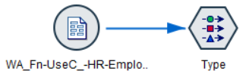

Step 2 : 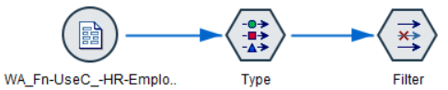

Step 3 : 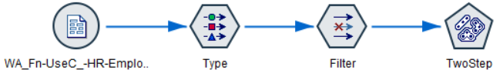

Step 4 : 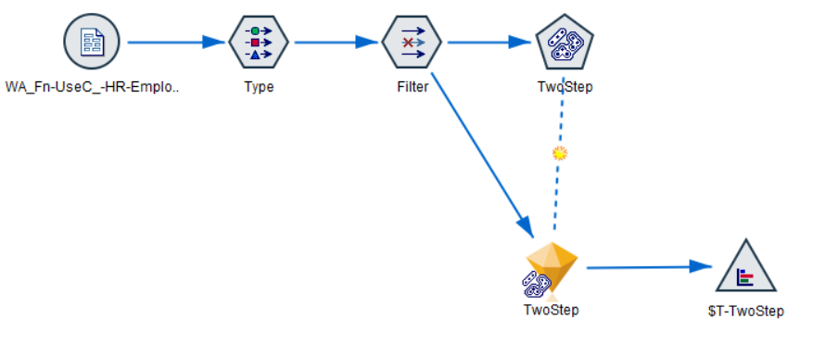

Outputs :

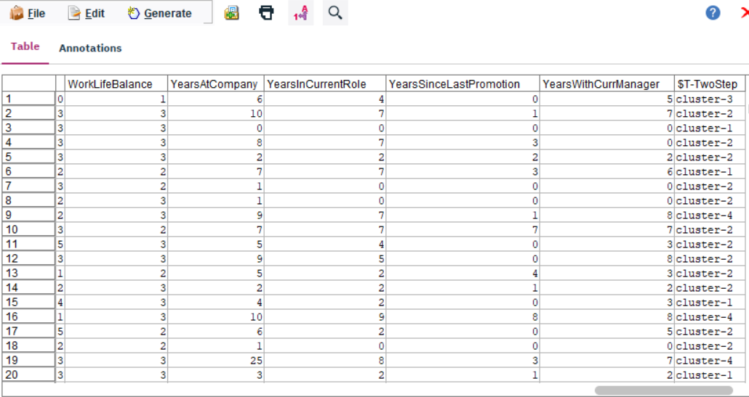
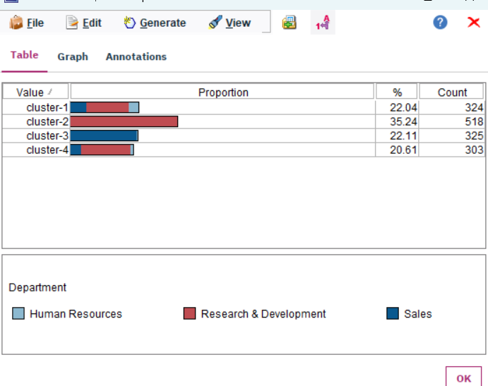
Key insights :
The Two-Step Clustering Model successfully transitioned the project from predicting individual outcomes to describing the overall workforce structure, providing the foundation for targeted HR strategy.
Insight Category | Key Finding from Cluster Profiles | Strategic Implication for HR
Workforce Structure | The model identified 4 distinct employee segments, proving the workforce is not uniform and requires differentiated management. | Move from "one-size-fits-all" policies to segment-specific interventions based on unique needs/risks.
High-Risk Segment | Profile (e.g.,ClusterX) is defined by Lowest Monthly Income, highest concentration of OverTime, and highest Attrition Rate. | Critical Intervention Point: Focus immediate retention resources (salary review, reduced workload) on this specific, high-risk group.
High-Value/Stable Segment | Profile (e.g., Cluster Y) is defined by Highest JobLevel, Highest Monthly Income, and Lowest Attrition Rate and YearsAtCompany. | Engagement Focus: Direct resources towards leadership development and long-term incentives to maintain loyalty and retention in this essential group.
Validation of Stagnation | A cluster often emerges (e.g., Cluster Z) characterized by High YearsAtCompany but only Mid-Range JobLevel and Income. | This visually confirms the statistical "loyalty penalty" found in the Linear Regression, highlighting a systemic need to review internal promotion and compensation policies for long-tenured staff.

MODEL 4

The fourth and final model utilized the C&R Tree (Classification and Regression Tree) Algorithm in its regression mode, with the goal of predicting the continuous outcome: Total Working Years. This model was chosen specifically because it is a non-linear, non-parametric technique, offering a valuable contrast to the initial Linear Regression model.
The primary purpose of this model was to move beyond the simple linear relationships found in Model 2 and generate easily interpretable, rule-based benchmarks for employee experience.
- Rule Generation: The C&R Tree works by segmenting the data based on a hierarchy of rules (e.g., "If Age AND JobLevel "), with each final segment (or leaf node) assigned a single predicted average for Total Working Years (e.g., 22 years).
- No Normalization Required: Like the Two-Step Clustering model, the C&R Tree requires no data normalization as it operates on the sorting and splitting of values rather than distance calculation, making the setup straightforward.

Steps for creating this model in IBM SPSS Modeler :

Step 1 :

Step 2 : 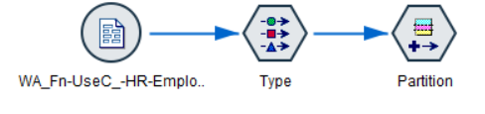
Step 3 : 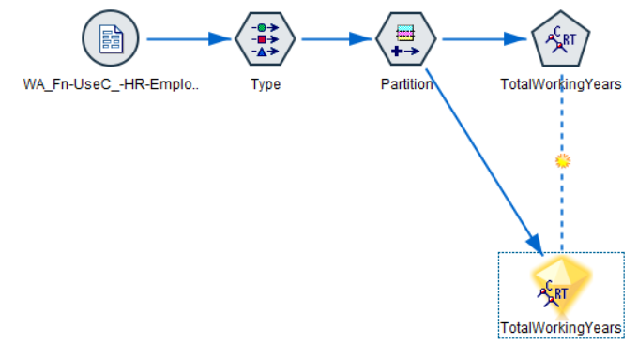

Step 4 : 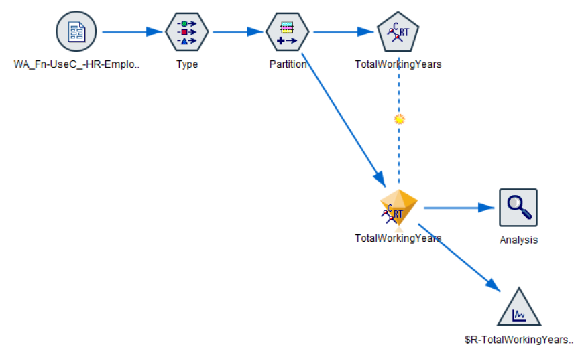

Outputs :
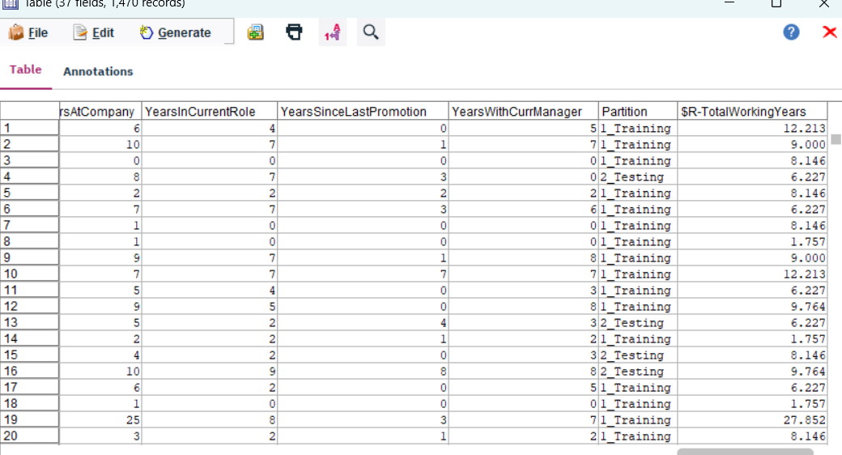
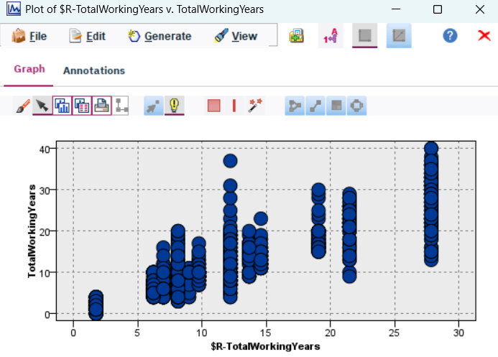
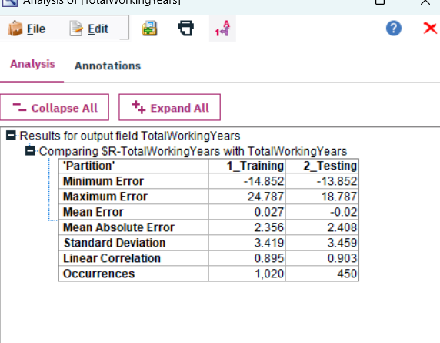

Key insights :
The C&R Tree model, predicting Total Working Years, provides powerful, non-linear, and rule-based insights into the factors that define an employee's overall career experience.
Insight Category | Key Finding | Strategic Implication for HR
Experience Benchmarking | The model creates rule-based segments, assigning a specific predicted average for TotalWorkingYears to each segment (e.g., 6.5 or 22.0 years). | HR can use these rules (e.g., "If Age and Job Level ") as objective benchmarks to verify if an employee's current role aligns with their expected career experience.
Dominant Predictors | The splits at the top of the tree confirm that Age and JobLevel are the most powerful factors defining an employee's total career history. | This reinforces the hierarchical structure: total experience is a function of chronological age coupled with the current attained career status.
Model Accuracy (RMSE) | The model's prediction error (RMSE) is measured directly in years (e.g., 2.5 years). | This quantifies the acceptable risk: the model's prediction for any segment's average total working years is, on average, off by X years.
Model Structure | The output plot shows distinct, vertical clusters rather than a smooth line. | This visually confirms the model is non-linear and works by segmenting the workforce into distinct experience groups (e.g., 'Junior', 'Intermediate', 'Senior') rather than providing a continuous prediction.

CONCLUSION

The completion of four distinct analytical models has successfully established a data-driven framework for human capital management, moving the organization beyond reactive HR policies to a proactive, evidence-based strategy. The project's findings synthesize into two major, actionable areas: mitigating retention risk and ensuring structural fairness.
The models highlight an immediate, critical risk: the C5.0 Classification model's low Recall (for Attrition) means that three out of every four employees who are about to leave are being missed, necessitating an urgent re-tuning of the model using misclassification costs. The Two-Step Clustering model then provides the solution for intervention by clearly defining the four key employee segments, allowing resources to be immediately targeted toward the High-Risk Segment (characterized by low income and high OverTime).
Furthermore, the two Regression models provided critical evidence regarding structural fairness. The Linear Regression model confirmed that Job Level is the overwhelming determinant of salary, but, more importantly, the negative coefficient for YearsAtCompany exposes a systemic flaw—a "loyalty penalty"—where long-serving employees who haven't been promoted lag in income. The C&R Tree model then provides the non-linear rules to address this, establishing clear benchmarks for expected Total Working Years based on job attributes.
In conclusion, the project delivers a diagnostic tool for organizational health, providing the necessary evidence to support an immediate policy review to eliminate salary stagnation and the final data to establish a transparent, equitable work environment.

